Capstone Project.
Login module
Sign in:
Admin or other type of user can login with emailId and password
Then open the dashboard.
Admin Dashboard
Add/Update/Delete/View and more operation.
Customer Dashboard.
Book cab and do the payment
View old booking history.
Sign Up: for admin account no signup with hard coding emaild and password as admin@gmail.com and password admin@123.
Type of user : admin/customer
Admin/teacher/student
Admin/customer
Frontend:
HTML, CSS, JavaScript and React JS

Backend:
Express JS with Node JS connecting database using mongo or mongoose module
npm init -y
npm install express mongoose bcryptjs

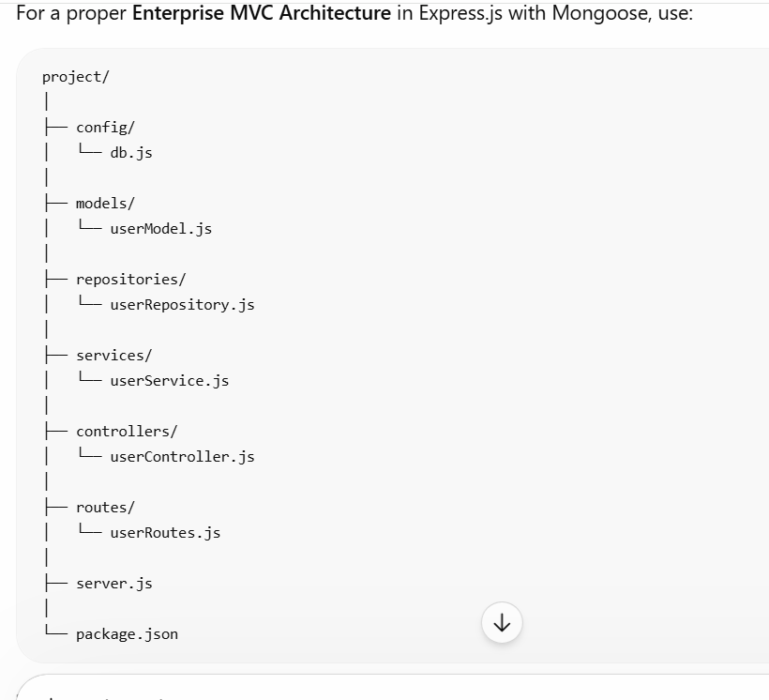

Database :
Mongo db

